**Understanding View in Asp.Net MVC:**

**DEF: UI Layer is called ASP.NET MVC View.**

**UI: User Interface**

**(Image,Text,Input Controls(Text,password,checkbox,List,…..)**

**Note:**

**In Previous class we saw just Controller + return string with/without parameter.**

**Now return View.**

**Asp.net MVC View:**

**================**

**Step 1: create controller**

**Step 2: add new action method inside your controller as follows.**

**Syntax:**

**public ActionResult metod()**

**{**

**return View()**

**}**

**Note: ActionResult,View –we don’t change built in.**

**We can change methodname and View argument or parameter.**

Right click 🡪 method name 🡪 add view

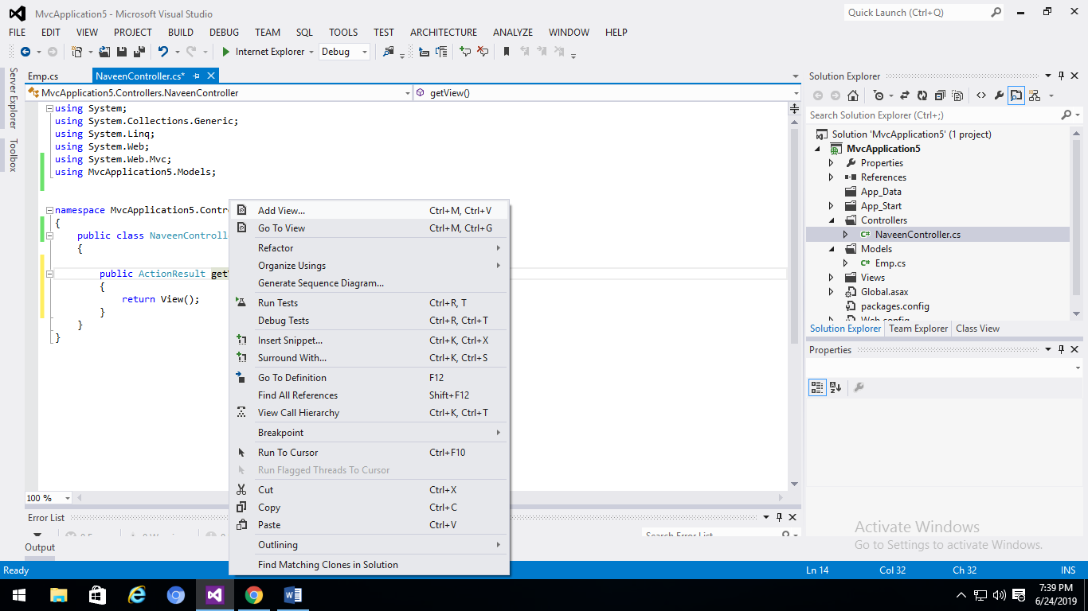

**Type view name 🡪uncheck use layout**

**Note: don’t forgot to add view name in return View(“MyView”)**

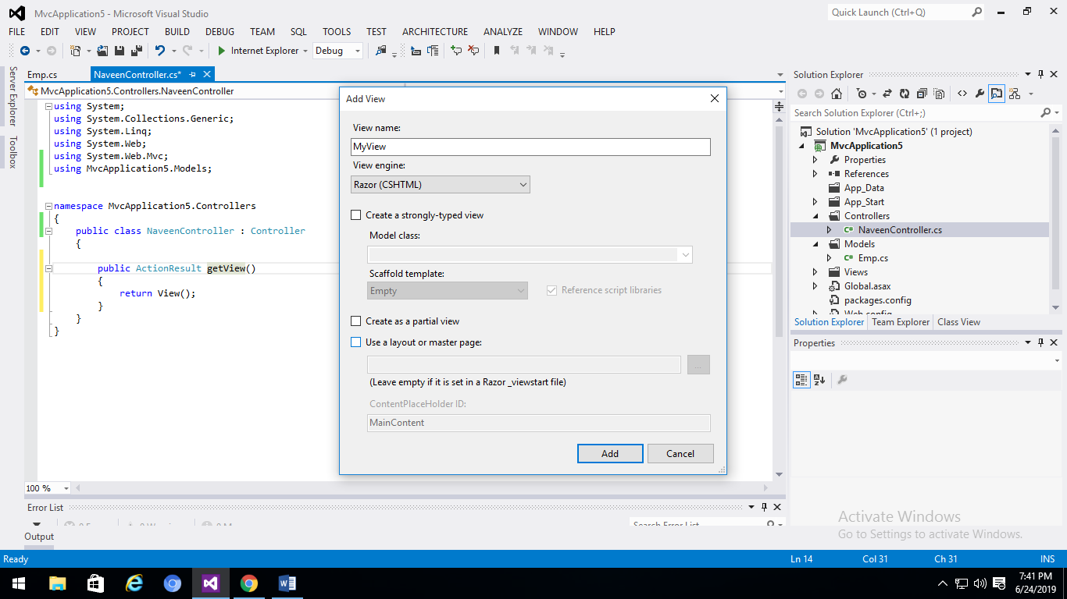

* **Add click.--> type html tag**
* 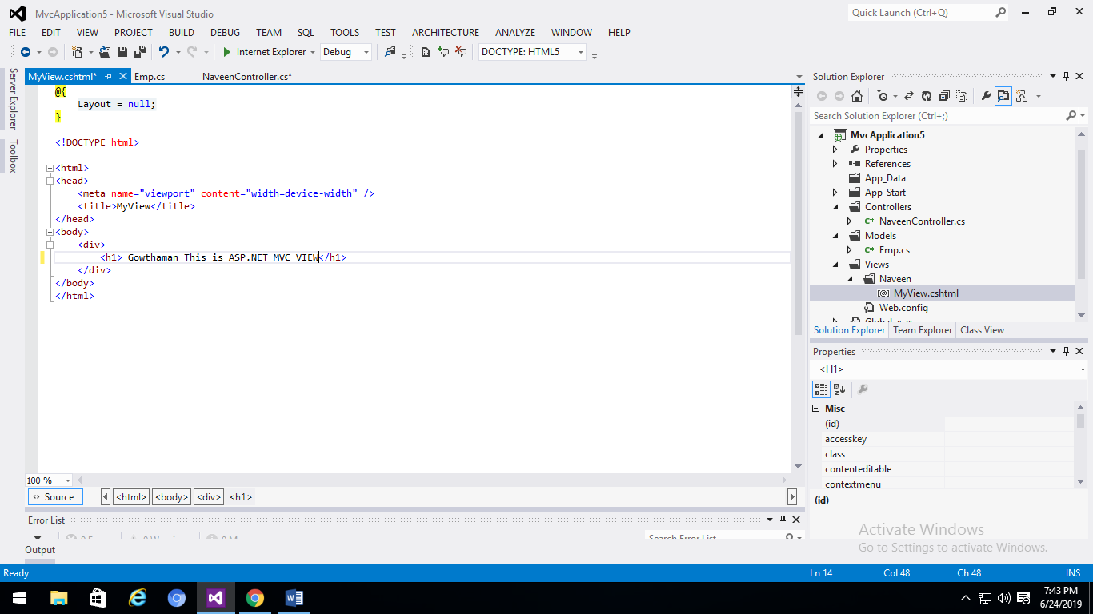
* **Run ctrl + f5**

